Project Design Phase
Solution Architecture

Date | 17 July 2026
Team ID
Project Name | CUSTOMER REGISTRY
Maximum Marks | 4 Marks

Solution Architecture:
The Customer Registry System follows a client–server architecture that connects users with a centralized database to efficiently manage customer information, complaints, interactions, and reports. The architecture ensures secure access, real-time data management, and seamless communication between the user interface, application server, and database.
The goals of the solution architecture are to:
- Design a secure and scalable customer management system.
- Define the interaction between the frontend, backend, and database.
- Enable efficient customer registration, complaint tracking, and interaction management.
- Ensure reliable data storage, authentication, and report generation.
- Provide a flexible architecture that supports future enhancements such as notifications, analytics, AI-based support, and payment gateway integration.

Example - Solution Architecture Diagram:
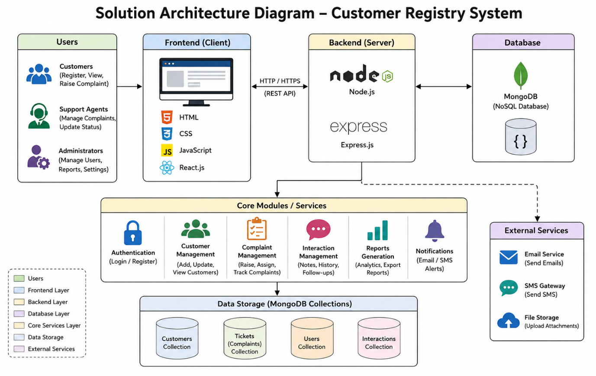

Figure 1: Architecture and data flow of the voice patient diary sample application
Reference: https://aws.amazon.com/blogs/industries/voice-applications-in-clinical-research-powered-by-ai-on-aws-part-1-architecture-and-design-considerations/

